Transformation Open Response:
Name:____________________________ Hour: ________

- Describe the symmetries of this cat tessellation.
    - 1 figure
    - A ‘block’ of figures
- Copy a portion (1 ‘block’ of figures is plenty!) of the tessellation and draw any centers of rotational symmetry or lines of symmetry.
- Describe the types of symmetries, and use degree measures in that description.
- Does it have point symmetry?
- Using the ‘four square’ black and white cats in the center of the cat tessellation picture, what type of transformation(s) do the two white cats represent?
- Again using the ‘four square’ black and white cats in the center of the cat tessellation picture, what type of transformation(s) do the left white cat, and the black cat beneath it represent?

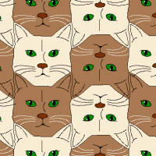

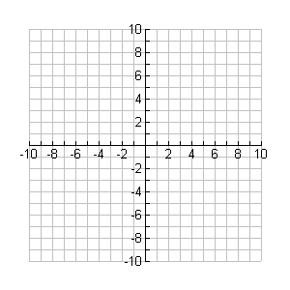
Resource: Andrew@cromp.com and artist Craig Kaplan at csk@cs.washington.edu

